https://www.youtube.com/watch?v=cuvsG-CiE8Y&list=PLsJW07-_K61L0J-nNoUjd9ALE3aUBFCrz&index=5

Azure Data Factory
Cloud based data integration service , that allows to create , schedule and orchestrate our ETL/ELT workflows at scale .
Extract, Transform, Load
Extract, Load, Transform
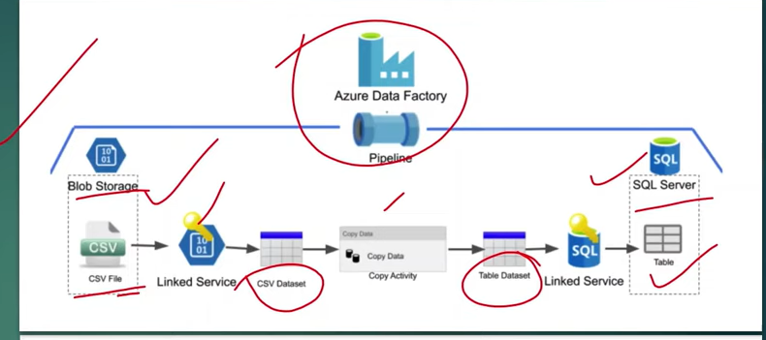
Pipelines , Linked Service , Dataset , Activites , Source , Sink

It contains few templates , which we can use if needed .
We can monitor the pipelines

Key Components of Azure Data Factory
- Activities
- Pipelines
- Linked services
- Datasets
- Dataflows
- Integration runtimes
- Triggers

40 is the maximum no of pipelines we can create in an ADF .

From linked services we can create data set and set that in copy data activity , source data set and sink data set .

Activities can be of 3 types ,
- Data movement activity
- Data transformation
- Control flow activity

Total there are 40 activities .

Different dependency conditions are : Succeeded , Failed , Skipped , Completed
Activity connection from one to another is using the above conditions

Paremeters Vs Variables

Parameters are defined at the pipeline level , and cannot be modified during a pipeline run .

@pipeline().parametes.<parameter name>

Unlike parameters , pipeline variables can be set and modified with a pipeline using a set variable activity .

@variable(‘varname’)

ERX File Processing

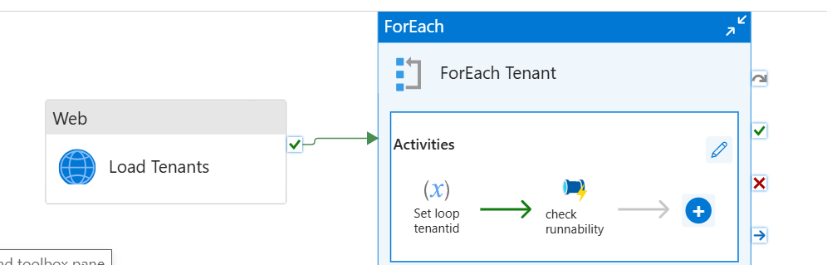

Load tenants is a web activity with http post call
@activity('Load Tenants').output.results

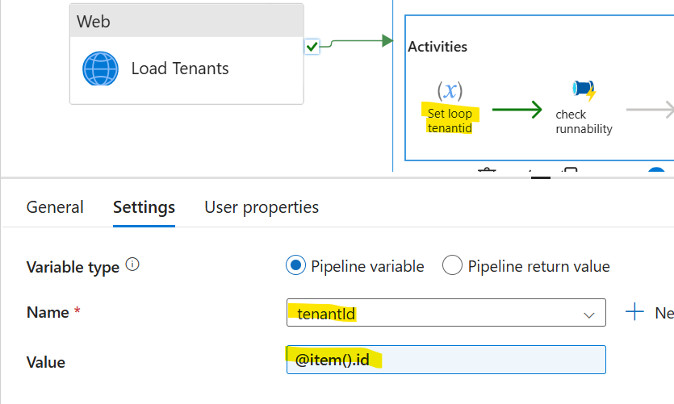

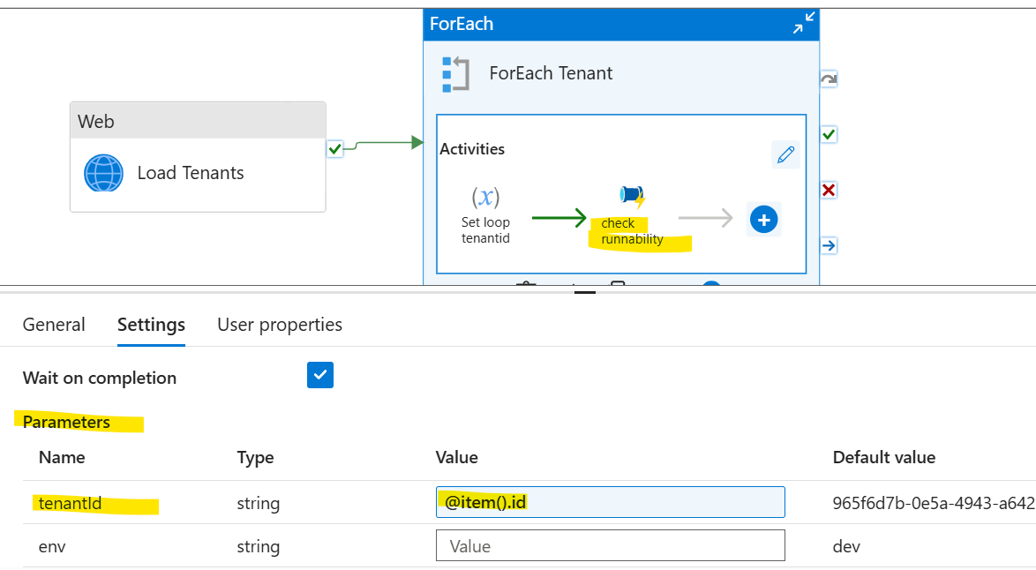

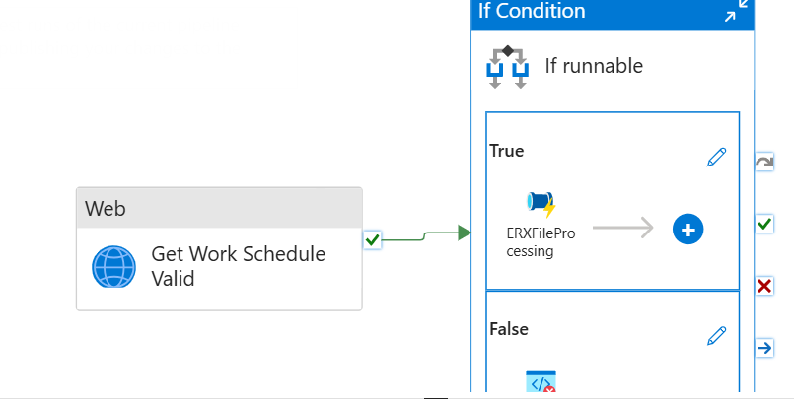

Expression of if condition
@activity('Get Work Schedule Valid').output.isCountyHoliday

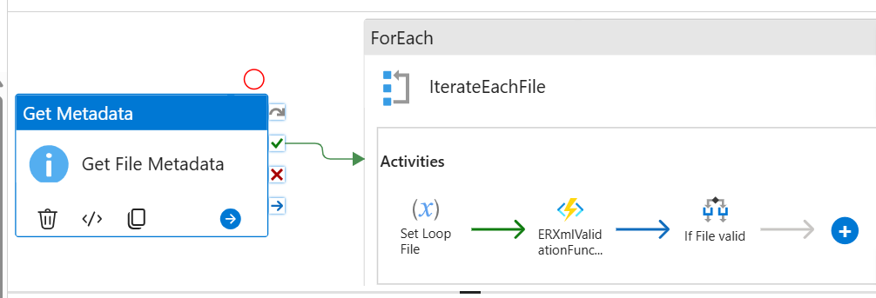

Get Metadata sets the properties for the dataset

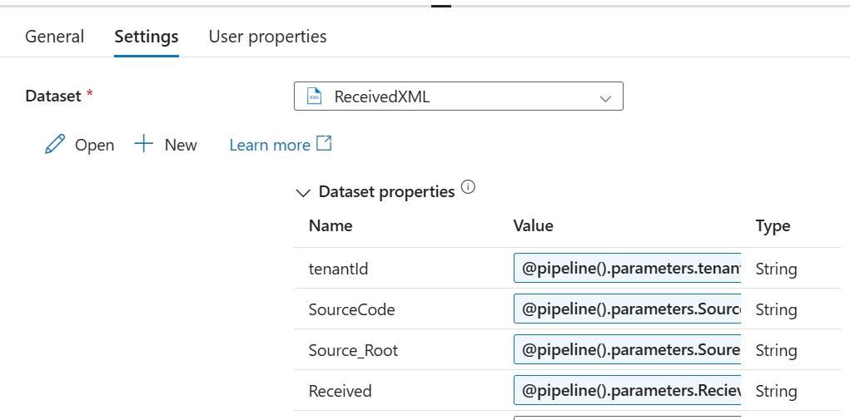

@activity('Get File Metadata').output.childItems
Loop through all the xml files
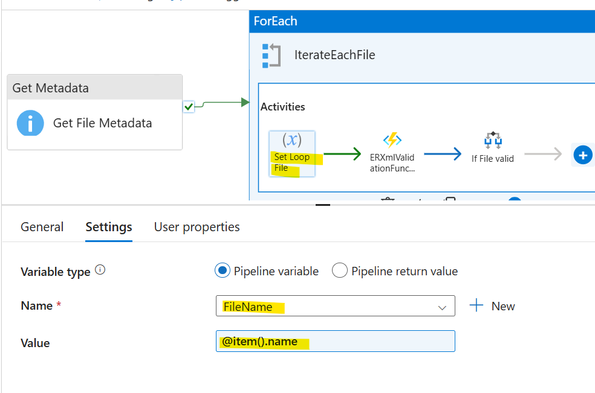

These go as headers to the function app call

xsdBlobName @concat( pipeline().parameters.SourceCode,pipeline().parameters.SoureRoot,'/Schema/ERX_Request.xsd')
blobName @concat( pipeline().parameters.SourceCode,pipeline().parameters.SoureRoot,'/',pipeline().parameters.RecievedFolder,'/',variables('FileName'))
tenantId @pipeline().parameters.tenantId

@equals(activity('ERXmlValidationFunction').output.Response,'false')

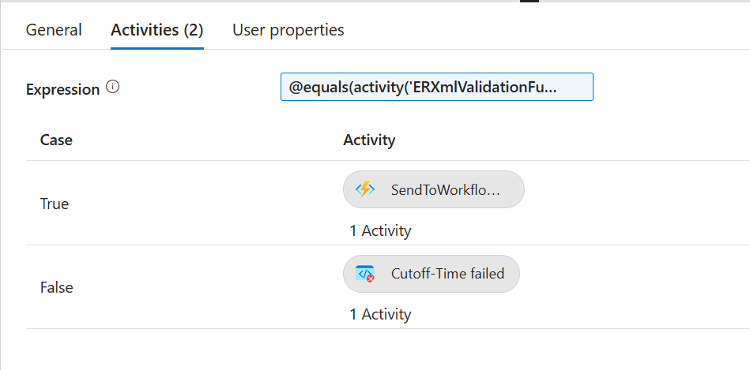

For send to workflow also we are setting the values in the request header

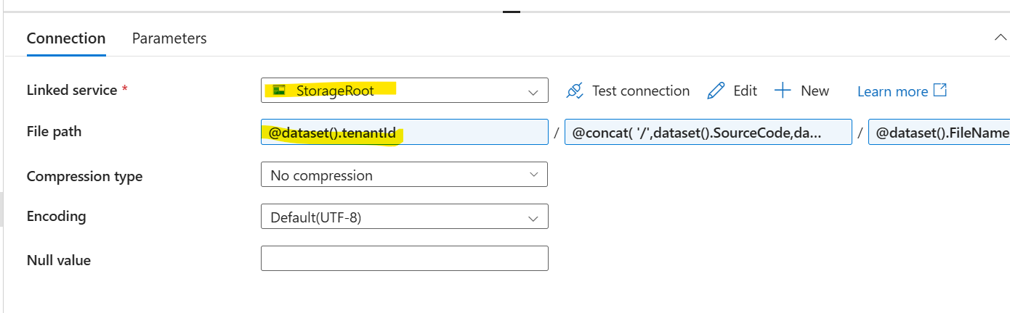

Data Flow

Mapping data flow in ADF provide a way to transform data at scale without any coding required .

It can contain multiple data sources .

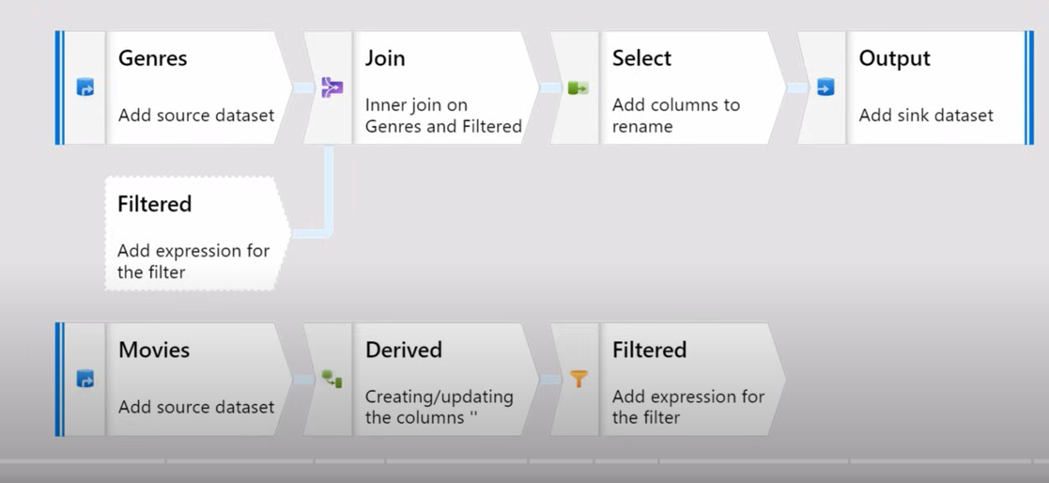

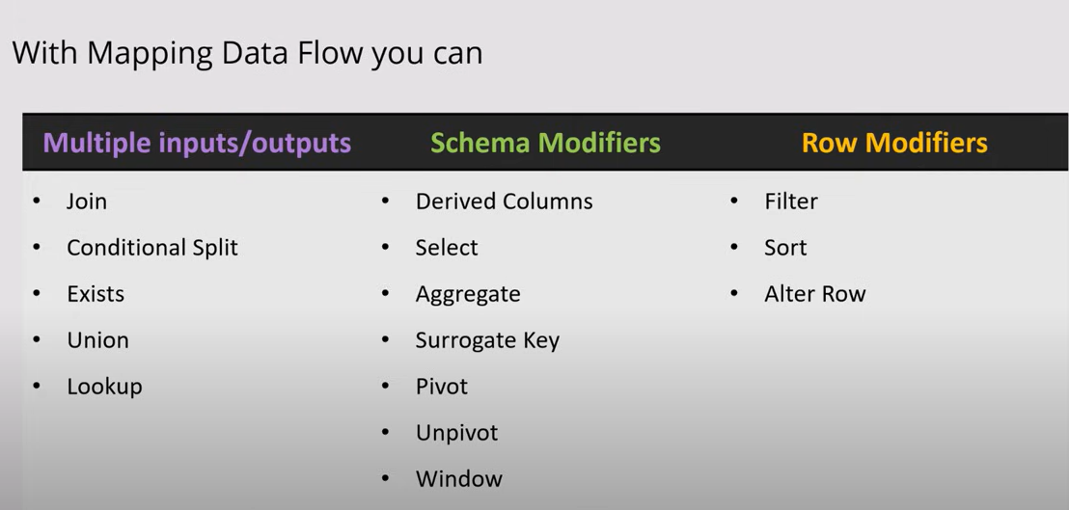

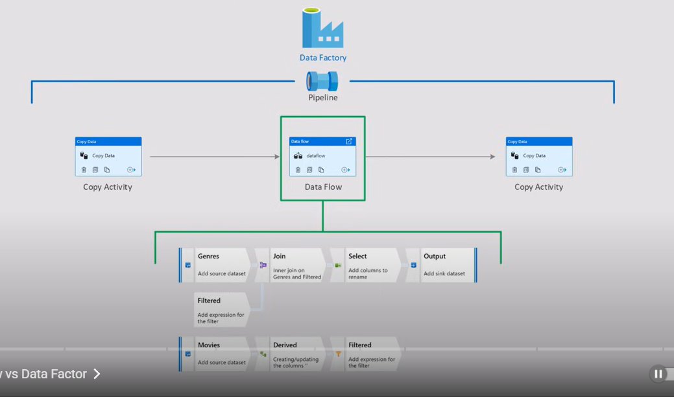

First one in the data flow is the source .

We can see , data preview
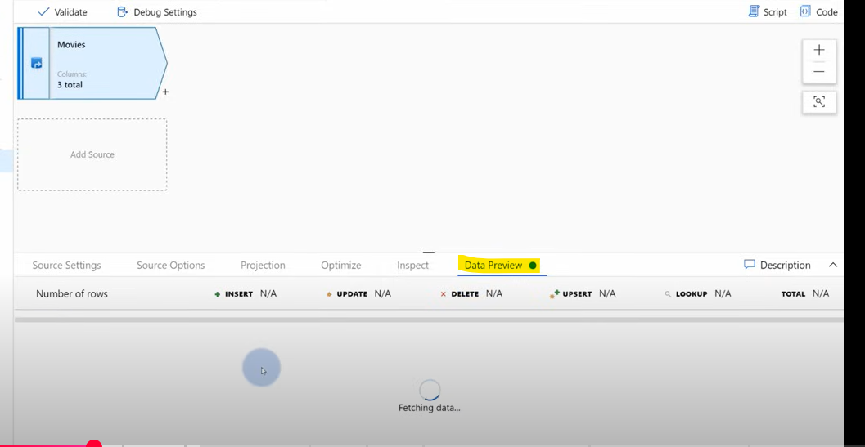

Data preview is available for every single step of data flow . we can use different scalar functions for formatting the data .

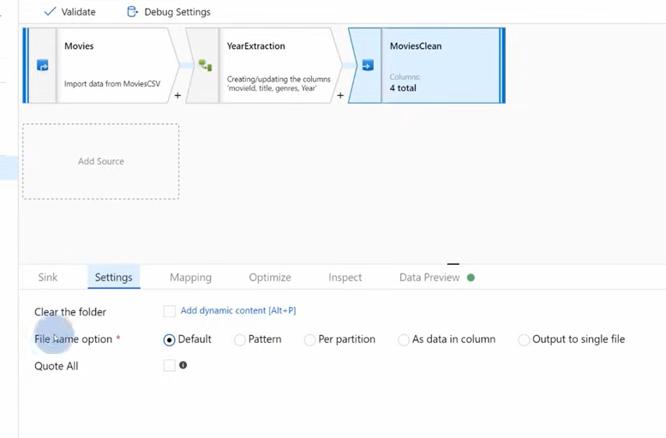

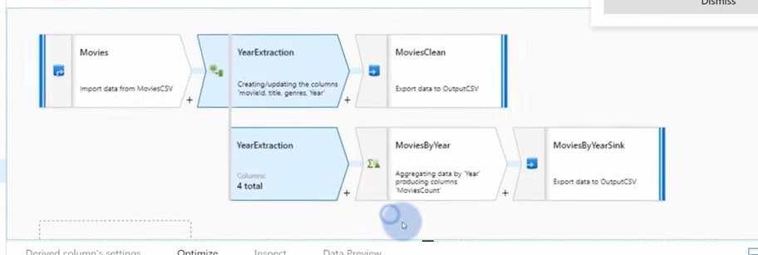

ADF Pipeline - Data Migration

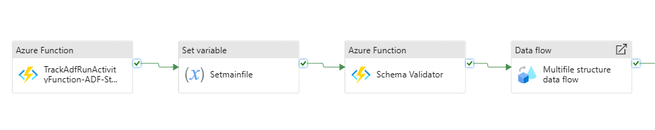
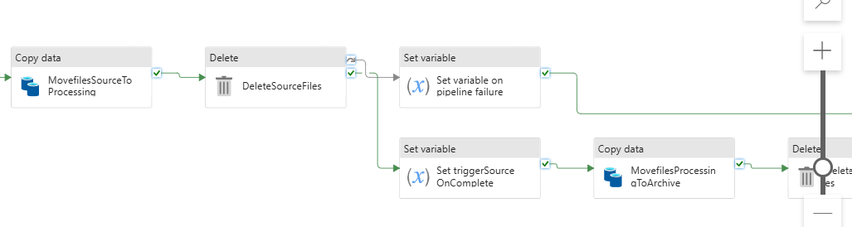

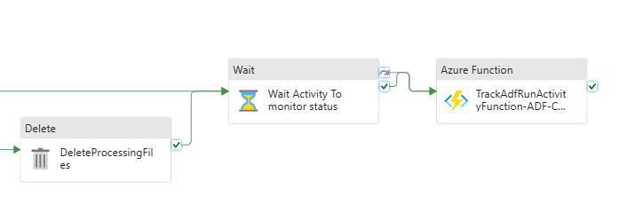
ADF started for setting the status for the Job TrackADFRunActivity

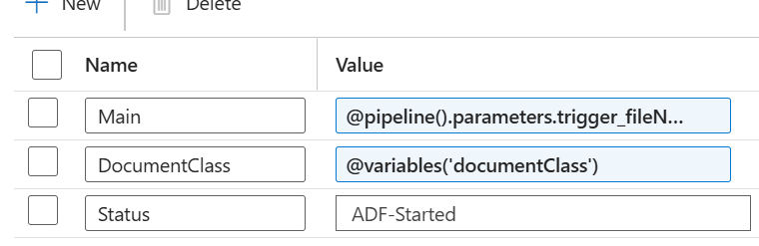

Set Variable for setting the value
Schema Validator for validating the schema

Multifile structure data flow
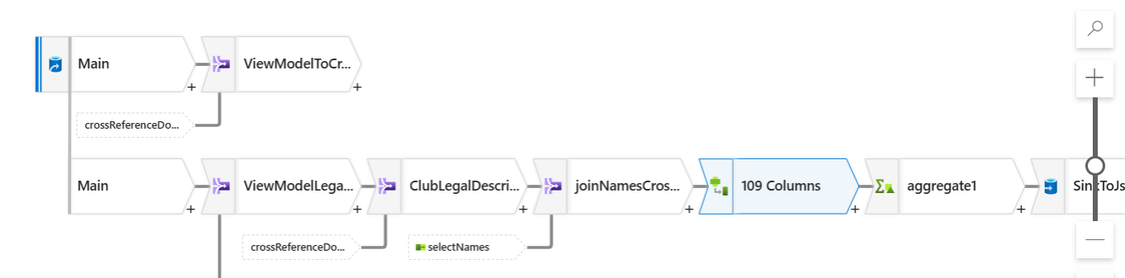

The main operations are Joins , Derived Columns , Aggregates , Select , Filters

At the end formatted JSON is add to a different sink storage account

